Chem 342 Lab: Synthesis of trans-phenyl styryl sulfone
Overview of the 2018 project
This year we will aim to synthesize trans-phenyl styrylsulfone (1) using electrochemical methods, starting from commercially available materials. If we find methods for making the cis isomer (2), these are also of interest as we can probably adapt them.
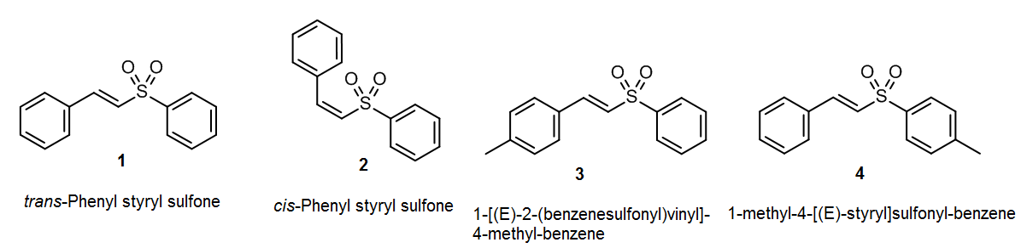
The goal of this project is to find a suitable electrochemical method for making compound 1 using any suitable method and starting materials. “Suitable” in this case means appropriate for undergraduates working with standard lab equipment and affordable chemicals, preferably within a normal laboratory period (3 hours). Compounds 2, 3 and 4 are not the target, but they may crop up in searches, and they are certainly relevant.
Search strategy
There is a good chance you will find an exact match for the target product, especially if you are using STN Easy/SciFinder or Reaxys. However if you’re unable to find an exact match, you will need to broaden the search terms enough to get useful hits, but not so much that you get too much, or things that are only tangentially useful. Since the para-methyl derivatives of the common reactants are commercially available, you can also search for these.
To understand the idea of broadening the search: Consider a geographical search; some maps cover the whole world, whereas some are just for the US, and some may be just for New York State. If you are looking for SUNY Potsdam on a map – if you don’t find it, you may decide to look for Potsdam. If you can’t find Potsdam, you may look for St. Lawrence County. If you can’t find the county, you may have to settle for New York State as the closest “hit”. The same will apply to your chemical search – and you will have to judge what searches are a good match.
Here are some suggested search methods:
Using search terms
Level 1: Exact – chemical reactants or products
For the phenyl styryl sulfone we only know the target product. Note that chemists often use trivial names, formulae or abbreviations in place of chemical names, even in the titles of papers.
“trans-phenyl styryl sulfone” AND synthesis
“[(E)-2-(Phenylsulfonyl)vinyl]benzene” AND synthesis
Level 2: Broader search
If this fails, try a broader search:
Strip away the numbers and prefixes and search for the word part of the name – that will help you find simple derivatives and related structures.
Using chemical identifiers (InChIKeys and CAS Nos.)
Level 1: Exact
Most useful with Google Web, ChemSpider, or similar. CAS numbers are commonly used, but may not be known for your product, so they may not be found. InChIKeys are only used rarely, but will give exact “hits” where they occur. Use combinations of InChIKeys if you have many hits.
(E)-Product (compound 1)
- Common name: trans-Phenyl styryl sulfone
- IUPAC name: [(E)-2-(Phenylsulfonyl)vinyl]benzene
- CAS No: [5418-11-1] or [16212-06-9]. Latter may represent unspecified stereochemistry.
- InChI: InChI=1S/C14H12O2S/c15-17(16,14-9-5-2-6-10-14)12-11-13-7-3-1-4-8-13/h1-12H/b12-11+
- InChIKey: DNMCCXFLTURVLK-VAWYXSNFSA-N
(Z)-Product (compound 2)
- Common name: cis-Phenyl styryl sulfone
- IUPAC name: [(Z)-2-(Phenylsulfonyl)vinyl]benzene
- CAS No: (Not known but sometimes given as [16212-06-9] – see above)
- InChI: InChI=1S/C14H12O2S/c15-17(16,14-9-5-2-6-10-14)12-11-13-7-3-1-4-8-13/h1-12H/b12-11-
- InChIKey: DNMCCXFLTURVLK-QXMHVHEDSA-N
First methylated product (compound 3)
- IUPAC name: 1-Methyl-4-[(E)-2-(phenylsulfonyl)vinyl]benzene
- CAS No: 30166-88-2
- InChI: InChI=1S/C15H14O2S/c1-13-7-9-14(10-8-13)11-12-18(16,17)15-5-3-2-4-6-15/h2-12H,1H3/b12-11+
- InChIKey: RBZQTVKSCWMGMH-VAWYXSNFSA-N
Second methylated product (compound 4)
- IUPAC name: 1-Methyl-4-{[(E)-2-phenylvinyl]sulfonyl}benzene
- [16212-08-1]
- InChI=1S/C15H14O2S/c1-13-7-9-15(10-8-13)18(16,17)12-11-14-5-3-2-4-6-14/h2-12H,1H3/b12-11+
- PIALZYNUNCIZLT-VAWYXSNFSA-N

